**Penn West Conference Mission Grants Awards, 2024**

This year, we rejoiced as 29 different churches in the Penn West Conference received $46,300.00 worth of grant monies for various projects in their ministries! This is the largest total amount we have ever awarded! Every church that applied received some amount of an award. We distributed grants for “Reaching Out” from our Corman Fund and our Neighbors in Need Fund. We distributed grants for “Strengthening the Church” from our Strengthen the Church Fund. We also distributed grants for “Operational Support” from our Kermit Thomas Bequest Fund, as well as our Caring for Churches, Caring for Clergy Fund. We are deeply grateful to our donors who have made these grants possible! We also hope that new donors will come forward who wish to be a blessing to many of our Penn West Conference churches.

The final reports for our 2024 grants are due by September 12, 2025. This is the means by which we hold our awardees accountable, and we provide them with reporting forms for this purpose. This year, we again provided a revised list of helpful tips for applying for grants on our website, and we hope that as churches become more aware of what is expected of them in the application process that more churches will avail themselves of the opportunities to receive these monies. We encourage all of our churches to apply and also encourage them to reach out to us if help is needed with the application process.

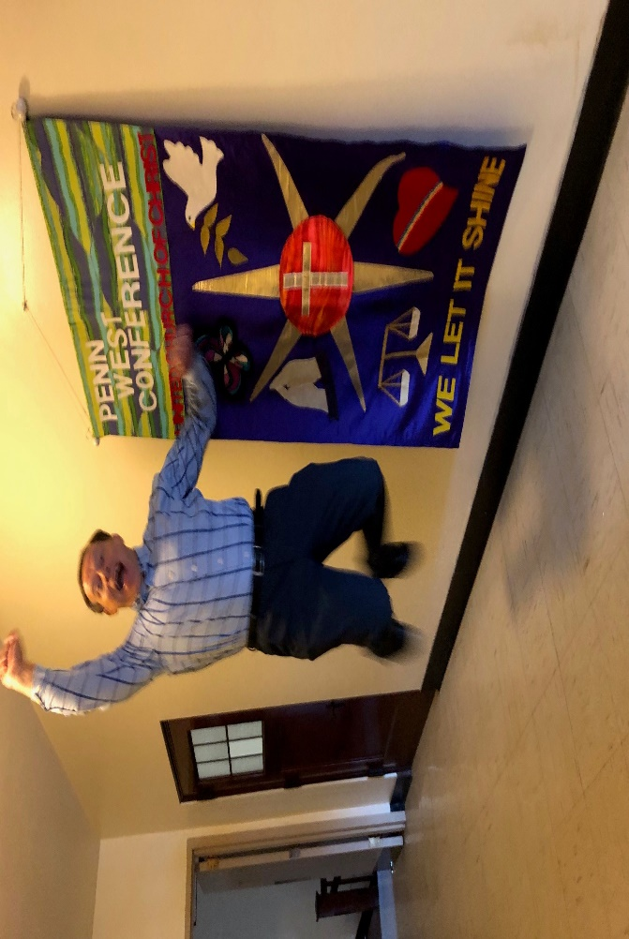

Here are our Mission Grant Awardees for 2024!

Congratulations to First UCC in Harrison City on receiving Penn West Conference Mission Grants for an Altar Table & Candles, Entrance Door Security Monitoring, and Parsonage Porch Replacement. Diane Fox presented this $3,000.00 total award to the Rev. John Titus!

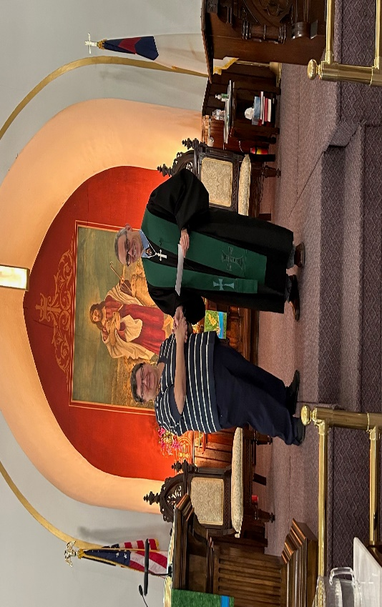

Congratulations to St. John's UCC in Darlington on receiving its first Penn West Conference Mission Grant! Receiving this $1,000.00 award for the church's Music Program are Karl & Bridget Horman.

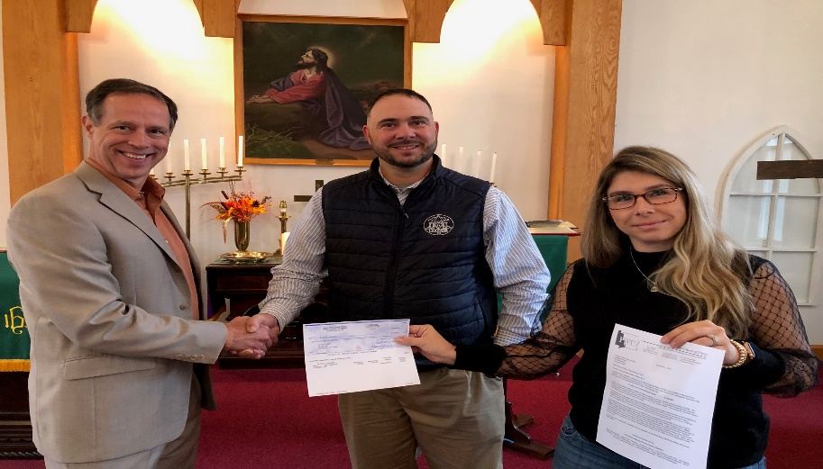

Congratulations to Christ UCC in Latrobe on receiving a $1,500.00 Penn West Conference Mission Grant for the church's Blessing Box! Receiving the award today are Dorthy Paulovich and Art Dira.

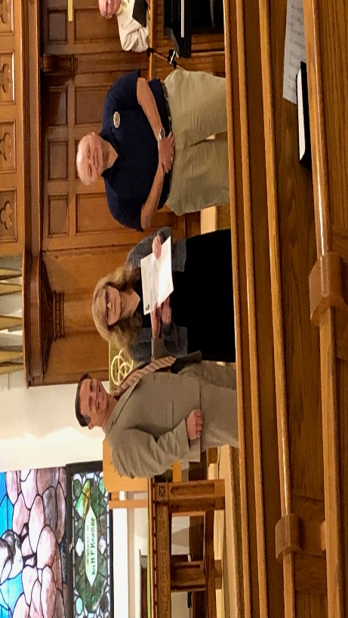

Alice Niebauer from our Penn West Conference Mission Grants Committee shared the following message on Facebook, "I was honored today to present a Mission Grant check from the Penn West Conference of the UCC to Rev. Nicole Pickens and Jim Biggart of Zion’s UCC, Transfer, PA. With this check, their church will continue to reach out to their community to improve lives through their backpack program and food pantry work. Congratulations Zion’s Transfer!" Thank you, Alice, and congratulations, Zion's UCC in Transfer!

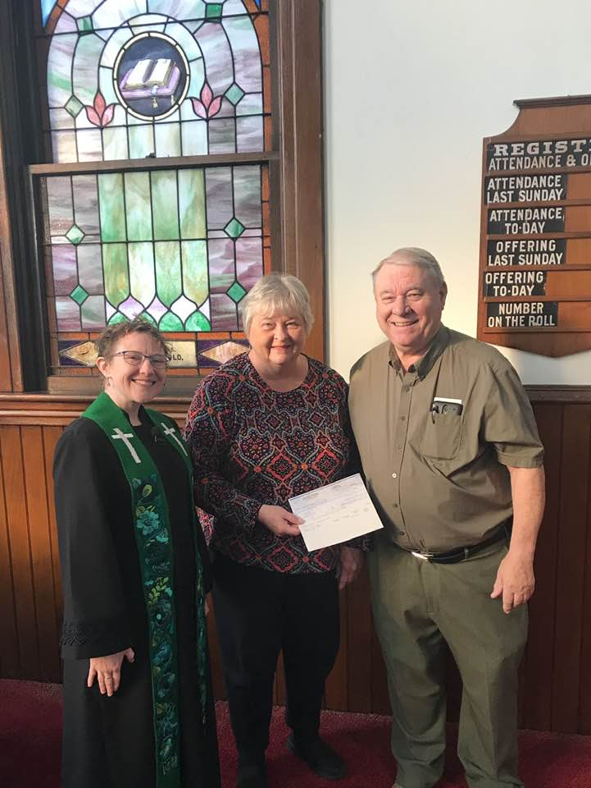

Alice Niebauer from our Penn West Conference Mission Grants Committee shared the following message on Facebook, "I was honored today to present a Mission Grant check from the Penn West Conference Association of the UCC to Consistory President Lori Tofani and Rev. Steve Craft of Zion’s UCC in Greenville, PA. With this check, their church will continue to improve how they deliver their message to their members and continue to reach out to their community. Congratulations to Zion’s UCC, Greenville!" Thank you, Alice, and congratulations to Zion's Reformed UCC in Greenville!

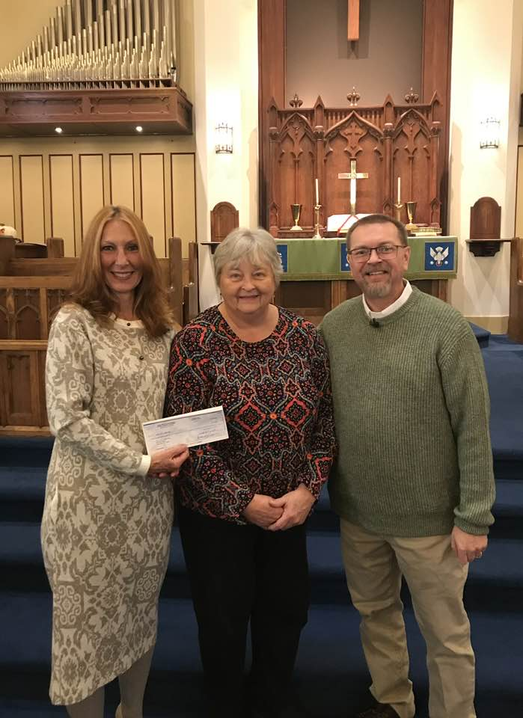

First Reformed United Church of Christ in Greensburg received a $1,500.00 Mission Grant from Penn West Conference this year for their Christmas Parade and a $1,000.00 award for repairs to their roof. Presenting the check to Sharen Logesky and Matthew Fox is Andrea Kopcak from our office staff.

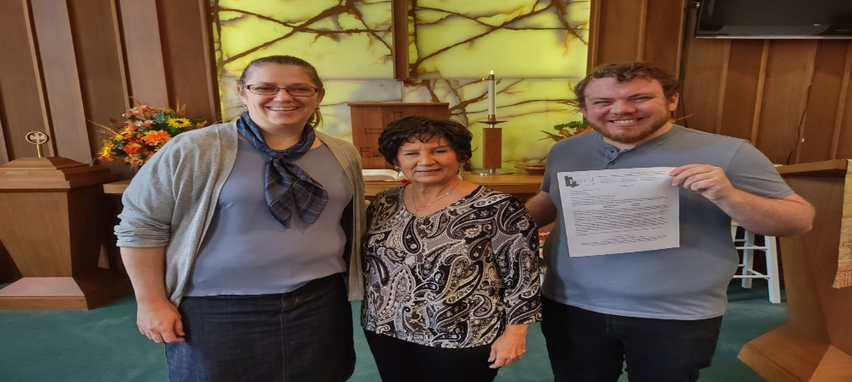

First Trinity United Church of Christ in Youngwood received their first Penn West Conference Mission Grant this year. They received a $1,000.00 award to help replace their boiler. Pictured here receiving the award from our office Secretary Andrea Kopcak are Kris Long and the Rev. Paul Sarver.

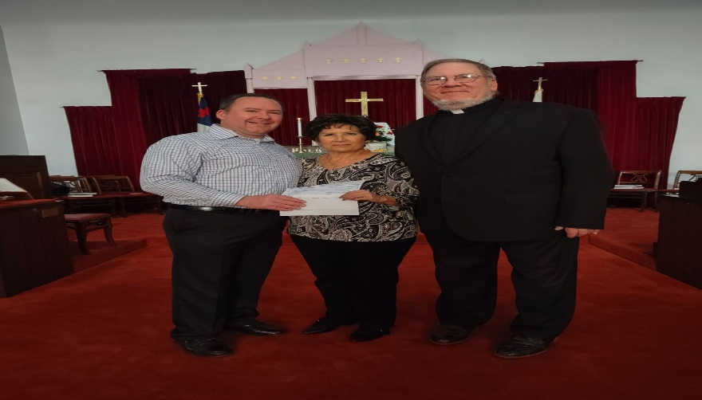

Trinity UCC in Greensburg received a $1,500.00 Mission Grant for their Blessing Box. Don Kelly from our Penn West Conference Mission Grants Committee is presenting the award to the Rev. Shirley Musick.

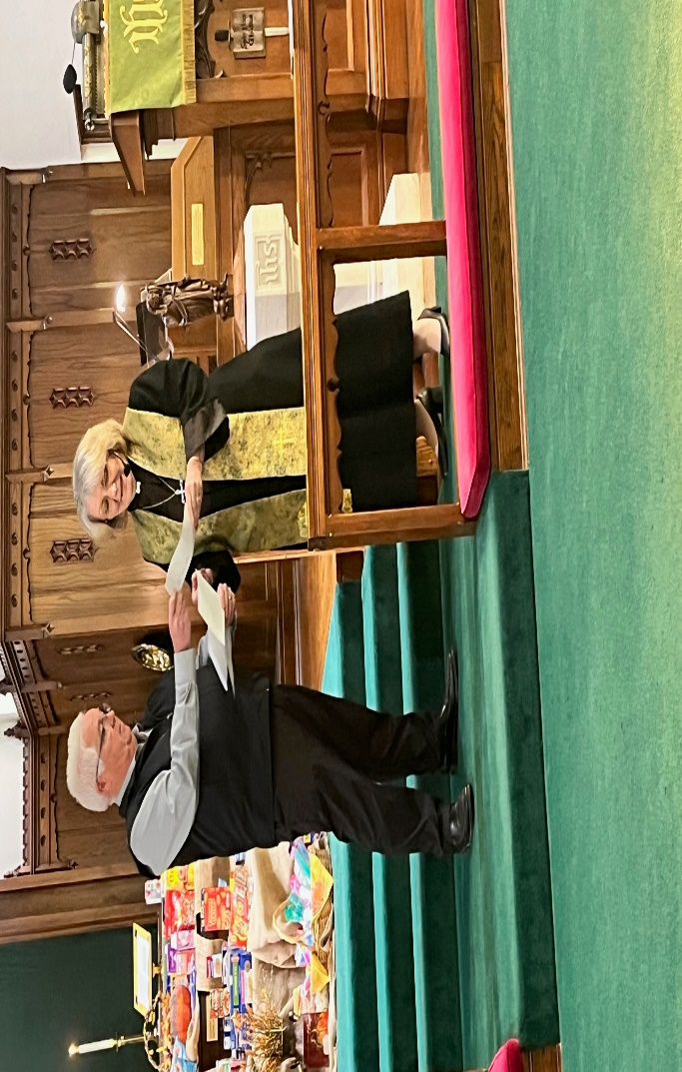

This Mission Grant was for $1,000.00 for "Copies and Communication." Thank you, Jon Colburn, and congratulations to First United Church of Christ in Millvale!

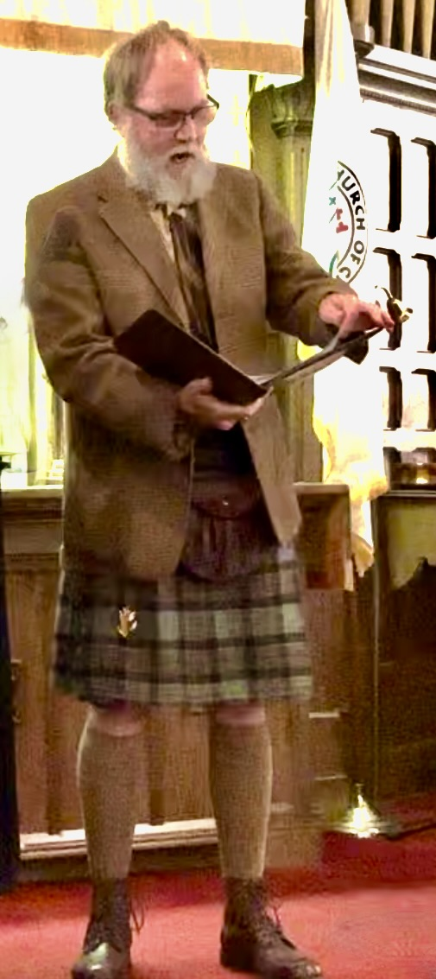

Congratulations to Denmark Manor United Church of Christ on receiving a $1,000.00 PWC Mission Grant for Boiler Chimney Repair and a $1,000.00 PWC Mission Grant for Speaker & Choir folders. Thanks to Shari Kelly for delivering the award on behalf of the Conference to Dave Conner from Denmark Manor.

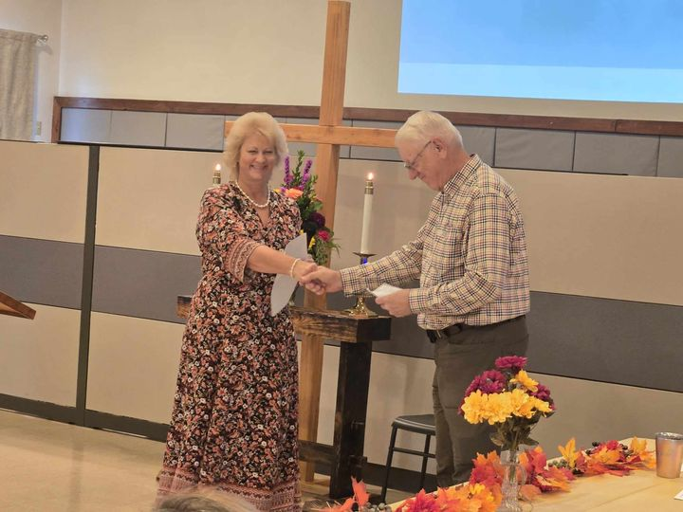

Congratulations to First UCC in Irwin on receiving a $1,000.00 PWC Mission Grant for Interior Wall Surface Restoration. Pictured here is Don Kelly presenting the award on behalf of the Conference to Tom Steiner of First UCC!

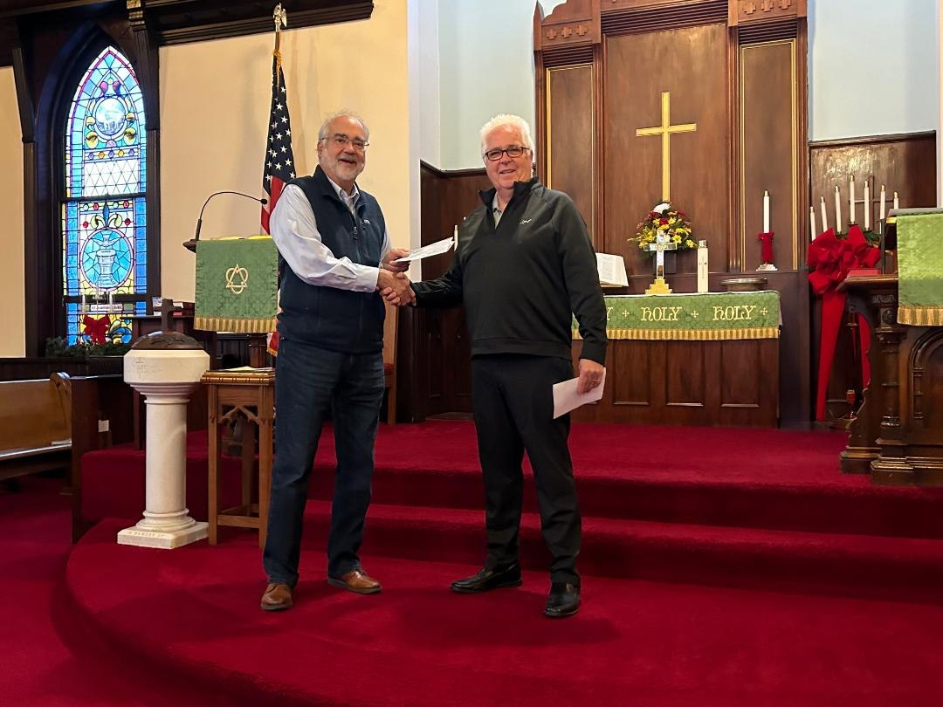

Congratulations to St. John's UCC in Larimer on receiving a $1,000.00 PWC Mission Grant for Live Streaming Church Services. Thanks to Andrea Kopcak for delivering the award on behalf of the Conference to James Harrison from St. John's!

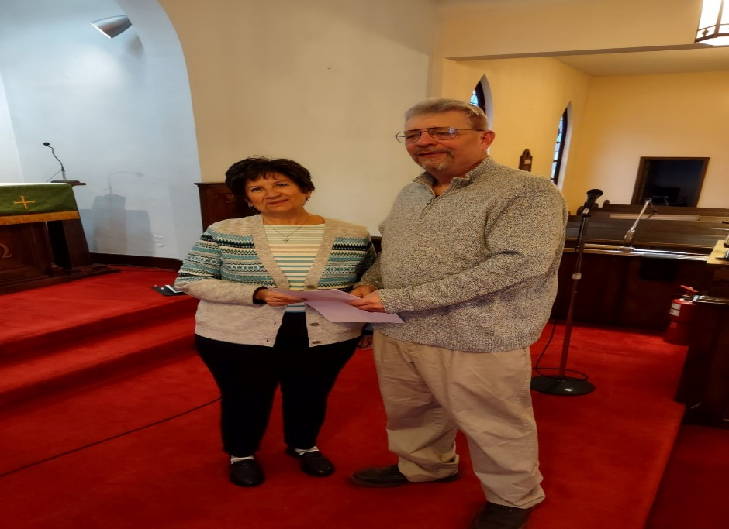

Alice Niebauer shared the following post on Facebook: "Congratulations to St. Paul’s Erie for receiving a $1,000 Mission Grant check from the Penn West Conference UCC for much needed roof replacement. Alice Niebauer presents the check to Pastor Chuck Nelson (left) and Council member Charlie Pierce." Thank you, Alice, for making this presentation on behalf of the Conference!

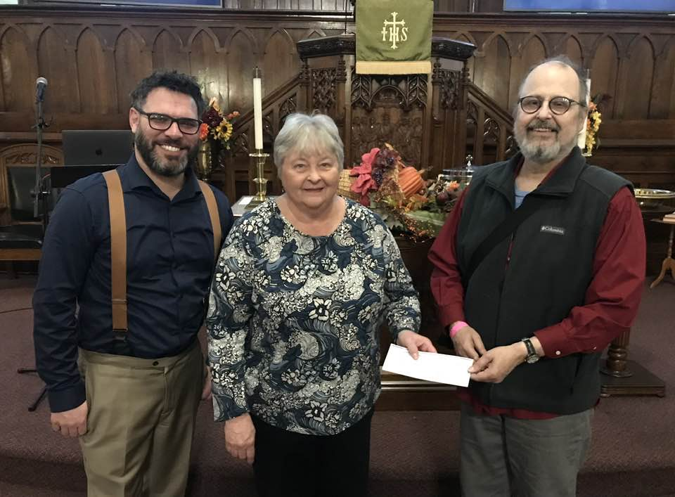

Alice Niebauer recently shared the following post on Facebook: "Congratulations to Community United Church, Erie on receiving a $4,000 Mission Grant check from the Penn West Conference UCC. Pictured are CUC members Ginnie Burger, Tracy Applebee-Davis, presenter Alice Niebauer and Pastor Joy Johnson." Thank you, Alice, for making this presentation on behalf of the Conference!

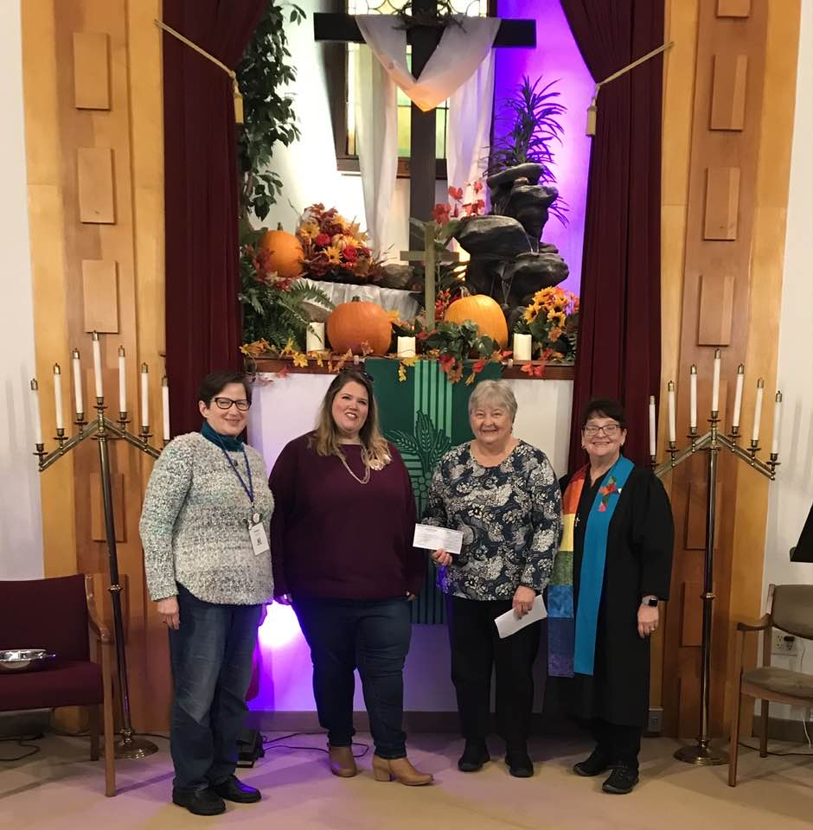

St. John's United Church of Christ in Evans City received an $800.00 PWC Mission Grant for Community Events, a $750.00 grant for Mission Projects, and a $1,000.00 grant for Elevator Test and Bell Risers. On behalf of the Conference, Jon Colburn is presenting this award to St. John's President Theresa Cook.

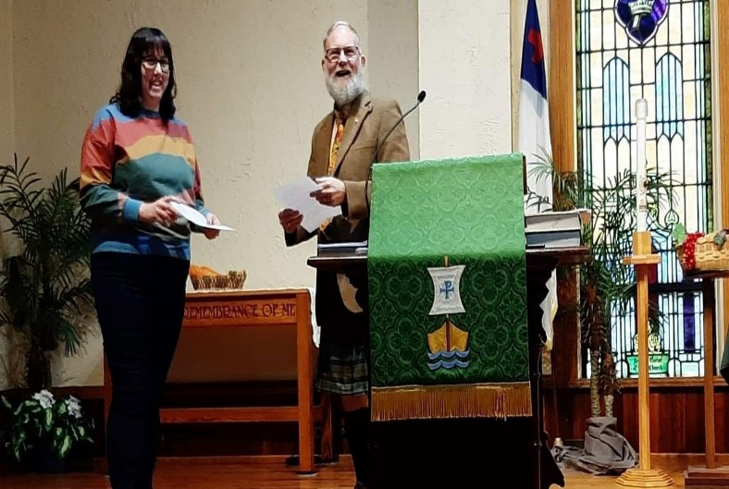

Congratulations to St. Paul's UCC in Somerset on receiving a $1,000.00 PWC Mission Grant for Parking Lot Safety! Marsha Ackerman is presenting the award to Andra Snyder, Jonathan Hillegas, and Pastor Matt Deal.

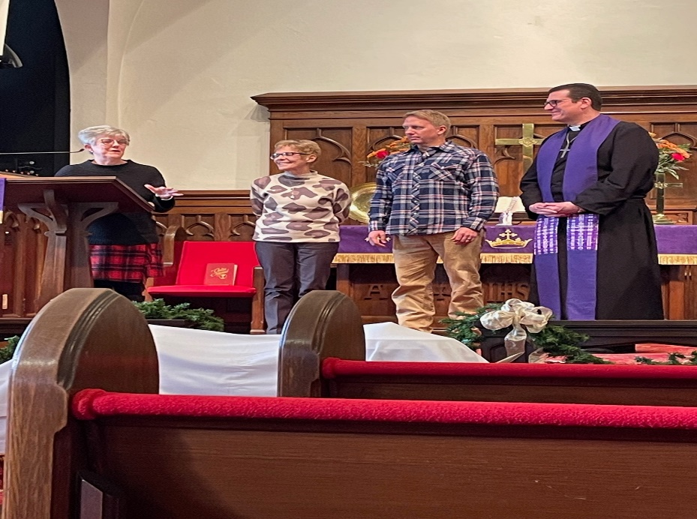

Congratulations to St. Paul's Evangelical & Reformed United Church of Christ in Johnstown on receiving a $1,000.00 PWC Mission Grant for a Heating & A/C Mini Split. Pictured here is David Ackerman presenting the award to Randy Datsko!

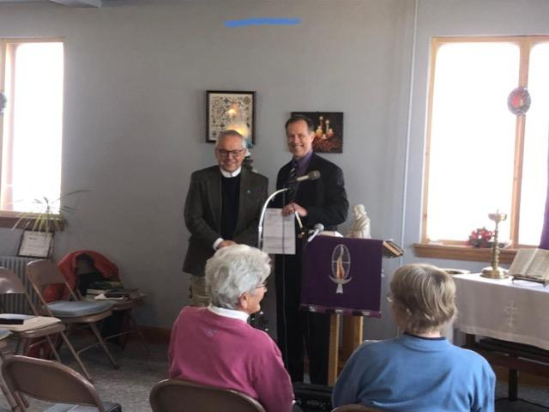

First United Church of Christ in Ebensburg received a $1,000.00 grant to Replace Window Frames and Glass. On behalf of the Conference, Dave Creamer is presenting the award to Andy Jones from First UCC.

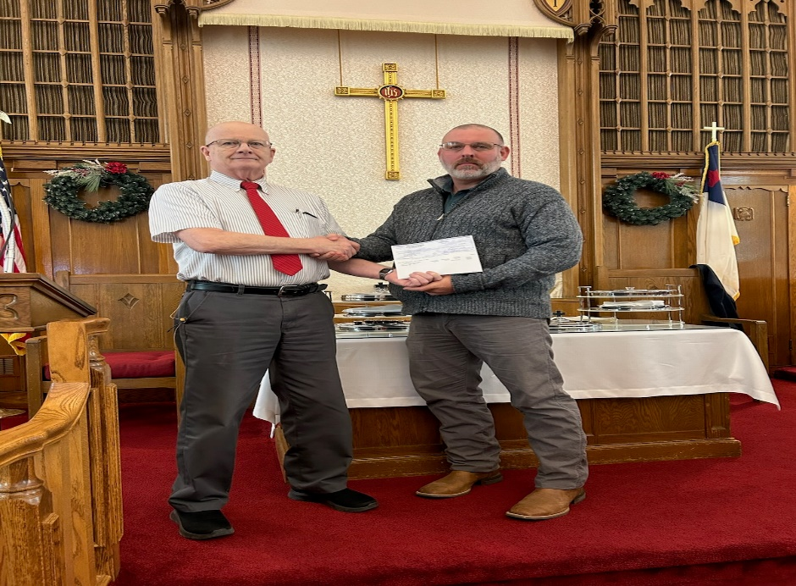

The Abbey Reformed United Church of Christ in Huntingdon received a $1,000.00 grant for their “Garments of Praise Paraments” project.

Mt. Hope United Church of Christ in Portage received a $1,000.00 grant for their “When a Door is Not Just a Door” project.

Greenfield United Church of Christ in Imler received a $1,000.00 award for their Hot Water Heater.

Grace United Church of Christ in Claysburg received a $1,000.00 grant for their “Seal of Approval” project.

St. Paul’s United Church of Christ in James Creek received a $1,000.00 award for their Wireless Mic System.

St. Paul’s United Church of Christ in Stoystown received a $1,000.00 grant for Upgrading their Computer for Easyworship and a $1,500.00 award for a trip to Lancaster for “Noah.”

St. Paul’s United Church of Christ in Connoquennessing received a $750.00 grant for Outreach Programs for their Ladies Aid Society and a $1,000.00 award for a Partial Roof Replacement/Drainage System.

Emmanuel Reformed United Church of Christ in Export received a $1,000.00 award for Restoring Sanctuary Painting.

Amity Reformed United Church of Christ in Meyersdale received a $1,000.00 grant for a Wi-Fi and Phone System Upgrade.

Jerusalem United Church of Christ in Rimersburg received a $1,500.00 award for their Blessing Kids Project and a $1,000.00 grant for their Online Computer System Upgrade.

St. Luke’s United Church of Christ in Kittanning received a $1,000.00 award for Concrete Repairs to their Entrances.

Congratulations to all churches who received Mission Grants this year. Please plan to apply for grants for your church next year, as we want to support our churches in their missions and ministries!